Frequent fire in northern California chaparral reduces post-fire shrub regeneration and native plant diversity

Grupenhoff, A1 & Safford, HD1,2

1Department of Environmental Science and Police, University of California, 1 Shields Ave, Davis, California 95616, USA

2Vibrant Planet, Incline Village, Nevada, USA

# Abstract

Like most of the western US, fire is an essential driver in maintaining species diversity and resilience in chaparral-dominated shrublands. Historically, chaparral burned at high intensity and had long intervals between fires. However, fire frequency has increased exponentially in this ecosystem with the rise of urbanization and an extended fire season. This departure has severe effects on biodiversity leading to exotic invasion and type conversion of shrubland to grassland. This has been well studied in southern California, but the timing and mechanisms of this process are poorly understood in northern California. This study examines how fire frequency affects the composition and abundance of herbaceous and woody species in the Coast Range of northern California, one of the most frequently burned areas in the state. Some studies have examined the effects of increased fire frequency in southern California but to date, no study has examined these effects at sites that have burned up to five times. Fifty-four 250-m2 plots were surveyed in 2021 and 2022 to measure changes in plant community composition and postfire regeneration of chaparral shrubs across a large gradient of fire frequency, up to six total fires in the last 20 years. [Add some results//major findings]

# Introduction

Fire is vital in maintaining biodiversity in many fire-adapted ecosystems across the western US, but interactions between anthropogenic drivers such as rapid climate warming, disturbance regime interventions, and land use change are reshaping these areas worldwide. In chaparral systems, we are seeing a hotter and drier climate leading to more extreme fire weather (Abatzoglou and Williams 2016; Keeley and Fotheringham 2001) and urbanization increasing the number of human ignitions (Keeley and Fotheringham 2003). These changes in climate and ignitions have altered natural fire regimes across the region.

Because the shrub canopy is short and mostly connected to surface fuels, California chaparral mostly burns at high intensity (Keeley and Safford 2016). Chaparral vegetation is adapted to moderately frequent fire, with paleodata and modeling studies suggesting an optimal fire return interval range between 30 and 90 years (Van de Water and Safford 2011). In the last 30-40 years, fire frequency has greatly increased in many areas dominated by chaparral, driven by urban expansion and increased anthropogenic ignitions, and interactions with invasive annual grasses, climate warming, and recurrent droughts (Syphard et al. 2006; Syphard et al. 2007). In southern California, large areas of lowland and lower montane chaparral have been converted to exotic grassland (Syphard et al. 2019; Park et al. 2018). This departure in fire frequency from historic norms has many implications for plant communities and often leads to exotic invasion and conversion to grassland (D’Antonio and Vitousek 1992; Keeley 2004). Some studies have examined the effects of increased fire frequency in southern California but to date, no study has examined these effects at sites that have burned up to six times. Additionally, only a handful of studies have focused on the Coast Range of northern California, one of the most frequently burned locations in the whole state.

Native chaparral shrublands of California provide critical ecosystem services (Underwood et al. 2018), however, uncharacteristically short fire return intervals threaten chaparral resilience and persistence. An increase in fire frequency has the potential to decrease plant diversity by eliminating species without adaptations to short fire return intervals. Many plants adapted to fire-prone ecosystems have traits that allow them to survive and regrow after fire or to rapidly recolonize burned areas (He et al. 2019). Postfire recovery includes factors such as regrowth,

reproduction, dispersal, germination, and establishment, all of which are mediated by how plant

traits interact with fire severity (McLauchlan et al. 2020). Specifically, postfire recovery in

chaparral involves regeneration initiated by germination of the dormant seed bank, resprouting

from lignotubers and other vegetative structures, or wind dispersal. Native woody species are

commonly divided into obligate seeders (species incapable of vegetative regeneration and are

present in the first postfire year by germinating from dormant seed bank), obligate resprouters

(which lack a dormant seed bank but regenerate vegetatively), and facultative seeders (which

have post-fire germination coupled with resprouting). We usually find that dispersal and invasion

into burn perimeters are of little importance to native species in these systems. Increased fire

frequency may induce substantial seed mortality for obligate seeders since these species often require a decade or more to replenish the seed back (Zedler et al. 1983; Jacobsen et al. 2004).

Some studies have also shown that even resprouting chaparral will be eliminated if fire is

frequent enough (Haidinger and Keeley 1993; Keeley and Brennan 2012). A change in fire history patterns may have more complex implications on the vegetative community and can ultimately lead to type conversion to a different community (Pausas et al. 2004, Keeley and Zedler 1998).

Shifts in composition and type conversion have large-scale implications for ecosystem resilience, regional and local biodiversity, and ecosystem services such as primary production, carbon sequestration, nutrient cycling, pollination, erosion mitigation, and habitat provision (Rundel 2018). Understanding the nuanced effects of fire recurrence on biodiversity and species composition is necessary for understanding future trajectories of chaparral type conversion. Once a community has undergone type conversion, it has a very low chance of reverting back to its historical condition, even if actively managed. Identifying areas that are in severe danger of type conversion, but are still intact, opens the possibility for preventative management. The direct impacts of climate change can also lead to changes in vegetation communities. However, changed fire patterns can accelerate, and in some instances, may be even more important than direct changes as a result of climate (Pausas et al. 2004, Flannigan et al. 2000).

Our study took place in the footprint of the Hennessy Fire from 2020. The landscape burned by the Hennessy has a rich fire history. 38% of the Hennessy Fire had burned in the previous 10 years, the highest of any 2020 fire, and more than 50% had burned at least once in the last 20 years (Safford et al. 2022). Some areas in the Putah and Cache Creek drainages had burned X times since 1990, and up to 4 times in the previous 7 years, which makes these areas among the most frequently burned in all of California. Despite the high frequency of recent fires in our study region, till now no one has examined how such high fire frequencies might be impacting ecological conditions in chaparral vegetation in northern California. Indeed, no published studies in California have evaluated the impacts of five or more fires on chaparral resilience. To understand when northern California chaparral communities lose resilience to invasion, we asked two primary questions: 1) How does fire frequency affect the diversity and cover of native and nonnative species and 2) What are the consequences of higher burn frequency on shrub seedling establishment and resprouting success. Based on results from studies in southern California, we hypothesized (1) a reduction in species diversity and local richness in areas with more than 2 short interval fires and (2) decreased native shrub regeneration and resprout growth of native shrubs. Specifically, local extirpation of obligate and facultative seeding species (2a) and a reduction in resprout growth of facultative species (2b).

# Methods

***Study Site and Sampling Design:***

Post-fire plant communities were sampled after the Hennessy Fire in chaparral shrublands of Northern California. Together, the Hennessy and the Walbridge Fires make up the LNU Lightning Complex Fire, which was one of the largest fires in California history. Both fires were ignited by lightning on August 17, 2020, and the Hennessy was not extinguished until early October after it had burned nearly 124,000 hectares in Napa, Yolo, Solano, and Lake Counties (Safford et al. 2022).

Vegetation in the study area is dominated by chaparral, grassland, and oak woodland. Our study focused on chaparral stands, which have successional relationships with both grassland and oak woodland. Historic fire-return intervals in California chaparral have been estimated between 30-90 years (Van de Water and Safford 2011) and the natural ignition sources prior to European colonization were lightning and burning by indigenous people who relied on chaparral plant communities for foods, medicines, and ceremonial items (Anderson and Keeley 2018). We find that humans are still the primary ignition source in this landscape but generally, we see more accidental ignitions from power lines, vehicles, and campfires rather than planned ignitions by Native people to maintain the distribution of chaparral (Anderson and Keeley 2018; Syphard and Keeley 2015). EXPLAIN these relationships and note that our study studies the chaparral grassland relationship. Now describe the chaparral vegetation we studied (Types – CWHR? MCV?; and major species).

Now describe the geography and the two study areas, give elevations and locations, Give temperature and precip data for the region, describe the soils and the geology. (I can help with this stuff)

In total, 54 plots were sampled at Quail Ridge UC Natural Reserve, Cold Canyon UC Natural Reserve, Cache Creek Regional Park, and Bobcat Ranch Audubon Reserve (Fig. 1). This area has a variable fire history, ranging from never burned to six prior burns in the past 30 years (Table 1). Plot locations were stratified across a fire frequency gradient and aspect, choosing an equal number of plots on north and south-facing slopes.GIS layers from the USDA Forest Service were used to extract the date of origin and fire size for fires that occurred during the past 30 years. Fire frequency was calculated using the California Fire Return Interval Departure database.

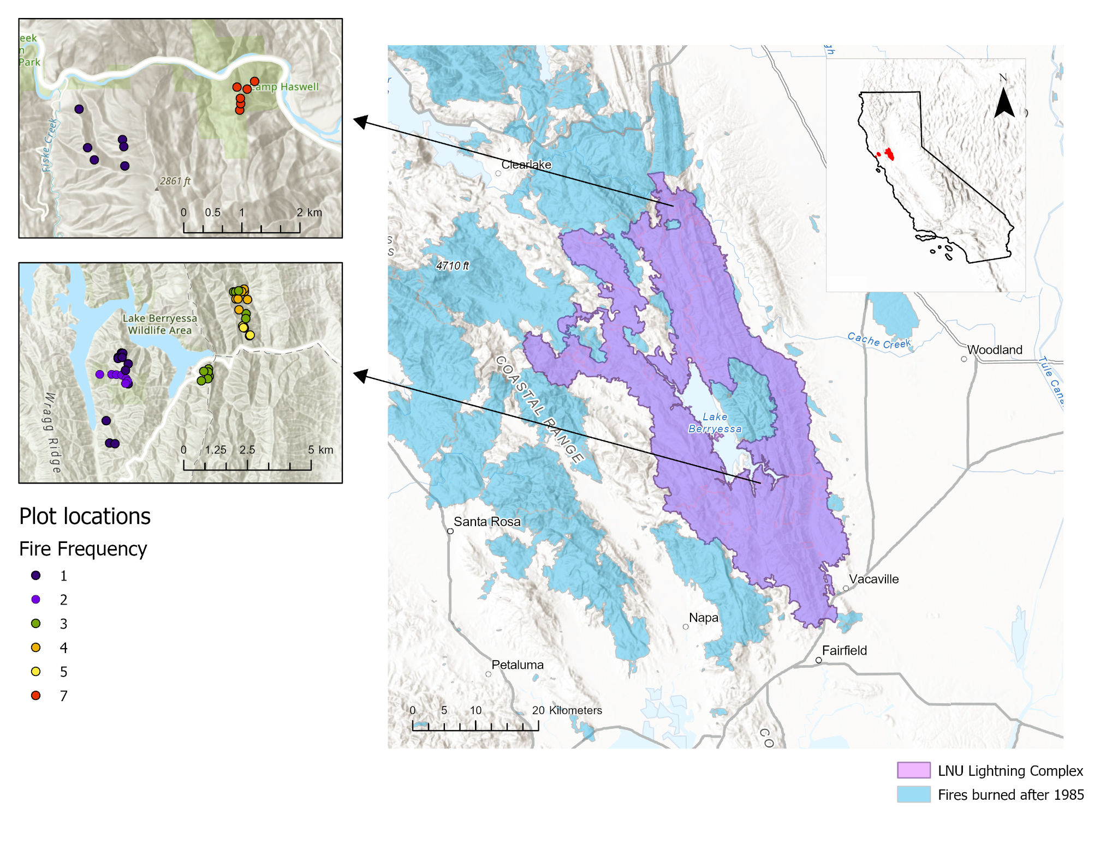

*Fig. 1. Map of LNU Lightning complex (purple polygon) with locations of prior fires burned since 1985 (light blue polygons). The figures to the left show plot locations, which were distributed across a fire frequency gradient of 1 total burn (blue) up to 6 total burns in the past 30 years (red).*

Table 1: Study sites across the LNU Lightning Complex

| Site | Jurisdiction | Fire History (since 1980) | Shortest interval between fire | Fire frequency (since 1980) |
| --- | --- | --- | --- | --- |
| Bobcat Ranch | Audubon Canyon Ranch | 2020 (Hennessey), 2018 (County), 2016 (Cold), 2014 (Monticello), 2007 (Braye) | 2 | 4-5 fires |
| Quail Ridge | UC Natural Reserve | 2020 (Hennessey), 2005 (Pleasure) | 15 | 1-2 |
| Cold Canyon | UC Natural Reserve | 2020 (Hennessey), 2015 (Wragg),  Miller (1988) | 5 | 3 |
| Cache Creek | BLM | 2020 (Hennessey), 2012 (sixteen complex), 2004 (rumsey), 2002 (sixteen), rumsey (1999), haswell (1987) | 2 | 1 & 6 |

At each of the 54 plots, 50 x 5-m belt transects were established following Safford and Harrison (2004) and Werner et al. (2021). Sites were visited in the spring of 2021 and 2022. All plant species were recorded within the entire 250-m2 transect to measure the overall richness of native and exotic plant species. Five 1-m2 quadrats were sampled at 10-m intervals along the transect line, measuring: the percentage cover of all native and exotic species; number and heights of shrub seedlings; resprout height; percentage cover of rock, bare soil, and litter; and litter depth. All variables collected at the 1-m2 scale were averaged to give a transect-level value.

The proportion of native species cover, richness, and diversity were calculated at each transect each year. We calculated the proportion of native plant cover in each plot as the total native cover/ (total native cover + total exotic cover). Local species richness was calculated as the mean number of species per 250m2 plot. Plot-level diversity was calculated using the Shannon-Wiener index, which gives weight to rare species.

Fire severity was estimated in each belt transect by measuring the stem diameter (1 cm from the terminus) of four stems from a randomly chosen *Adenostoma fasciculatum* (chamise) individual rooted in or adjacent to each quadrat (Perez and Moreno 1998). Additionally, five more individuals were measured at the entire 250m2 transect scale. In cases when chamise was not present (rare) we used *Heteromeles arbutifolia* or *Quercus berberidifolia* individuals. We measured heterogeneity in fire severity within each belt transect by calculating the coefficient of variation for the five quadrats within a transect.

Plant life history data for each species were obtained from the USDA Forest Service Fire Effects Information System or the University of California Jepson Herbarium. Species were classified to origin (native, nonnative), lifecycle (perennial, annual), lifeform (tree, shrub, forb, graminoid, fern), and fire regeneration strategy (obligate seeder (OS), facultative seeder (FS), obligate resprouter (OR)) using the Raunkiaer (1934) classification system

***Statistical analyses***

*Species cover, diversity, and composition*

Bayesian generalized linear mixed models were used to investigate the interaction between fire frequency on the proportion of native species richness and cover using a Beta Binomial likelihood (Equation 1), which accommodates values between 0 and 1, for both survey years. To determine which environmental covariates to add to the model, we used the expected log pointwise predictive density (ELPD) as a measure of leave-one-out cross-validation for our goodness of fit measure. The covariates that we evaluated were fire frequency (numBurn), mean annual precipitation, mean annual temperature, heat load index, and aspect. We verified that independent variables were not highly correlated (ADD FIGURE SUPPLEMENT). We first fit the proportion of native species cover with each individual predictor separately and added significant predictors in order of ELPD to determine whether they significantly increased ELPD of the resulting model.

*Equation 1:*

$prop.nativecover_{i,j} \sim Beta(μ_{i,j },ϕ)$

$logit(μ_{i,j }) = α + β_{numBurn}numBurn +β_{numBurn}numBurn^{2} + β_{SurveyYear}SurveyYear$

$α \sim student_t(3, 0, 2.5)$

Non-metric multidimensional scaling (NMDS) was used to visualize compositional differences between areas with variable fire recurrence as a part of the ‘vegan’ package in R (Oksanen et al. 2011). This ordination uses rank-order correlation and Bray-Curtis dissimilarities to model the differences among treatments based on species composition and abundance of all plant species.

*Shrub regeneration*

We used a similar modeling procedure to understand how fire frequency influenced shrub regeneration. We fit seedling presence/absence using multiple Bayesian generalized linear models with Bernoulli likelihood (Equation 2). Similarly to species diversity, we used the ELPD as a measure of leave-one-out cross-validation for our goodness of fit measure to compare. We first fit the presence/absence of a seedling with each individual predictor separately and added significant predictors in order of ELPD to determine whether they significantly increased ELPD of the resulting model. The covariates that we evaluated were fire frequency (numBurn), mean annual precipitation, mean annual temperature, heat load index, and aspect. A separate model for facultative and obligate seeding species, and for each individual species separately.

Equation 2:

$presence \sim Bernoulli(ρ_{i})$

$logit(ρ_{i}) = α +β_{numBurn}numBurn +β_{SurveyYear}SurveyYear$

$a \sim student_t(3, 0, 1)$

All models were created using the brm function in the brms package (Burkner 2017) in R version 4.1.1 (R Development Core Team 2022). Continuous independent variables were centered and scaled prior to analysis. We used mildly regularizing priors to prevent overfitting with used 4 chains, each with 2000 iterations and a warmup of 1000. Trace plots and R-hat values were assessed to confirm proper mixing and model convergence.

# Results

*Fire severity*

Mean and maximum fire severity, as well as the heterogeneity of fire severity, were reduced in areas with short interval fire (>2 in the past 30 years) (Fig. 2, Table 2). Fire severity (which is inversely related to the diameter of the measured stem termini) was high in sites that only burned once before the Hennessy Fire, but low in all other fire frequency classes (differences among FF = 3, 4, 5, and 6 were not statistically significant).

*Species cover, diversity, and composition*

In total, 223 species were found throughout the study area. As predicted, we found that the proportion of native species cover, the proportion of native richness, and the proportion of native Shannon diversity declined with increased fire recurrence in both survey years (Fig. 3). The effect of fire recurrence was strongest for the proportion of native cover (βnumburn = -0.51; CIs = -0.65 to -0.37) and moderately strong for the proportion of native species richness (βnumburn = -0.19; CIs = -0.27 to -0.11) and Shannon diversity (βnumburn = -0.19; CIs = -0.28 to -0.09) (Tables 3a-3c).

Plots in areas with different fire frequencies had different species assemblages. The NMDS ordination of species composition resulted in an overlapping cluster of plots with higher fire recurrence (>2 short interval fires) that contain more nonnative herbaceous species, while plots with lower fire recurrence (≤ 2 short interval fires) contained more native herbaceous species and shrubs (Fig. 4). Species characteristic of the high fire frequency plots included *Avena* *barbata*, *Centaurea* *melitensis*, *Erodium* *cicutarium*, and *Festuca* *myuros* (Fig. 4), all classic dominant species in the exotic annual grassland that characterizes highly disturbed sites in lowland California. Plots with higher fire recurrence had smaller clusters compared to areas with low fire recurrence, indicating a shift from a more heterogeneous post-fire landscape to a more homogeneous landscape with many similar nonnative species.

*Shrub regeneration*

Short fire return intervals in northern California chamise chaparral reduced shrub seedling regeneration (Fig. 5). Overall, seedling regeneration of FS declined by 83% and OS regeneration declined by 99% in the most frequently burned plots (fire recurrence = 7). OS species, including *Ceanouthus oliganthus* and *Ceanthous cuneatus,* were almost completely eliminated in areas with >2 fires in the past 20 years (Fig.6). We found a strong negative association between fire frequency and the occurrence of OS regeneration (βnumburn = -0.85; CIs = -1.36 to -0.45) and a significant, albeit less strong, negative association between fire frequency and the probability of occurrence of FS regeneration (βnumburn = -0.19; CIs = -0.32 to -0.06). Although we found moderate evidence for the negative influence of increased fire frequency on facultative seedling regeneration, this trend was species-specific (Fig. 7). Fire frequency significantly reduced the occurrence of *Adenostoma fasciculatum* (βnumburn = -0.54; CIs = -0.86 to -0.06) and *Lepechinia calycina* seedlings(βnumburn = -0.41; CIs = -0.77 to -0.11). We found a slight qualitatitive increase in *Eriodictyon californicum* seedlings(βnumburn = 0.07; CIs = -0.14 to 0.27), however, this effect was not significant.

Table 2: Measures of fire severity (mm) (± SE) across fire frequency gradient.

| Fire frequency | 1 | 3 | 4 | 5 | 7 |
| --- | --- | --- | --- | --- | --- |
| Mean fire severity (mm) | 1.17 ± 0.24 | 0.24 ± 0.03 | 0.13 ± 0.01 | 0.22 ± 0.02 | 0.32 ± 0.02 |
| Coefficient of variation in mean fire severity (%) | 88.1 | 40.6 | 21.1 | 28.9 | 18.3 |
| Maximum fire severity (mm) | 2.45 ± 0.48 | 0.49 ± 0.07 | 0.21 ± 0.03 | 0.40 ± 0.04 | 0.47 ± 0.02 |
| Coefficient of variation in max fire severity (%) | 83.3 | 50.0 | 54.4 | 19.7 | 12.0 |

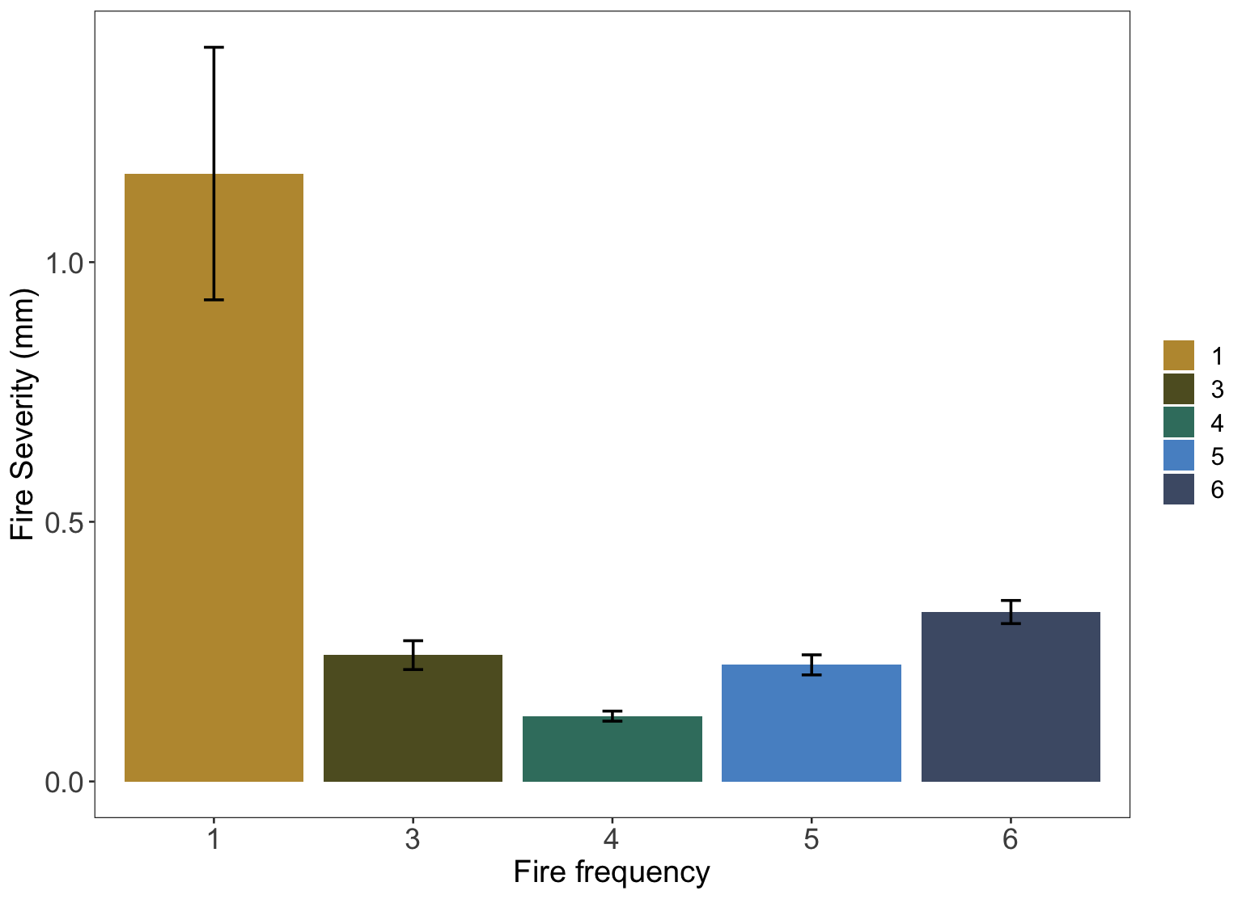

*Fig 2: Measures of mean fire severity (mm) (± SE) decrease with multiple short-interval fires.*

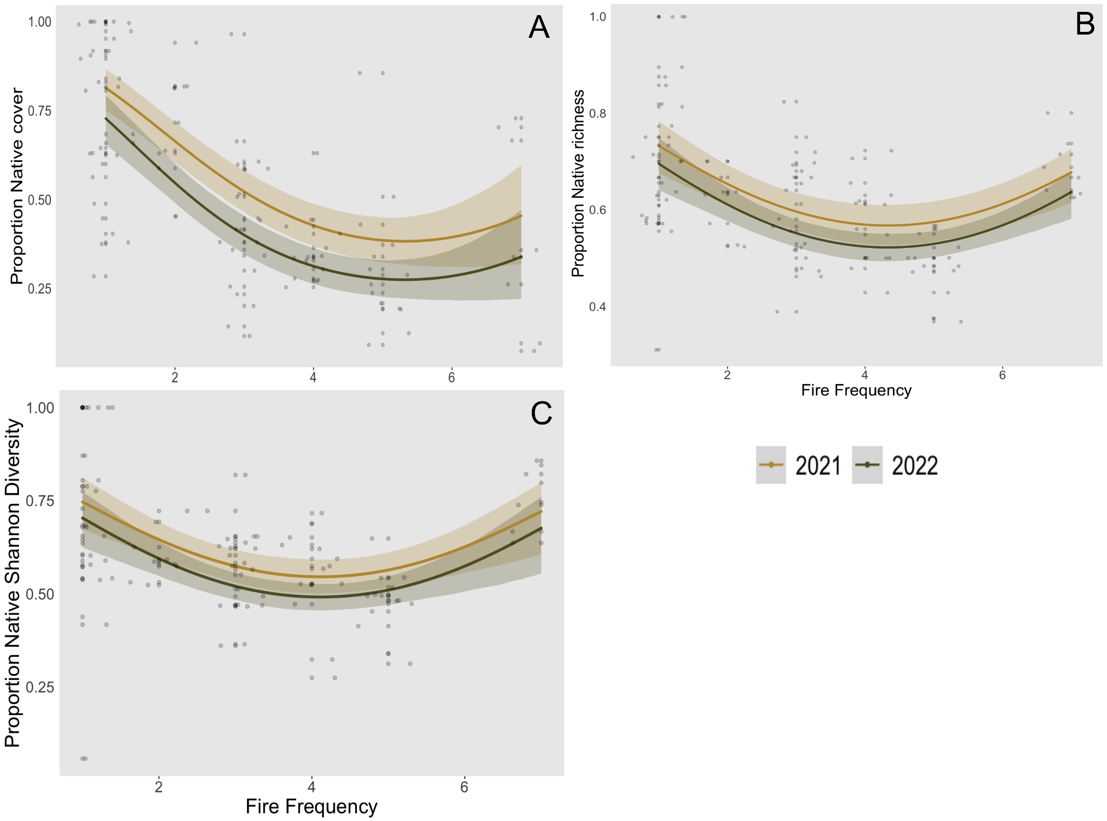

*Fig 3: Proportion of native species cover (A), richness (B), and Shannon diversity (C) at the plot level declines with increased fire frequency. Predicted values from the top-ranked Bayesian model with 95% credible intervals, as well as raw values (grey circles, n=103).*

*Table 3a: Model summary for Bayesian model fit for the proportion of native species cover.*

|  | Estimate | Est.Error | Lower 95% CI | Upper 95% CI | Rhat | Bulk_ESS |
| --- | --- | --- | --- | --- | --- | --- |
| Intercept | 2.50 | 0.38 | 1.73 | 3.24 | 1.00 | 2620 |
| Num_burn | -1.12 | 0.21 | -1.52 | -0.70 | 1.00 | 2524 |
| Num_burn2 | 0.10 | 0.03 | 0.05 | 0.16 | 1.00 | 2548 |
| 2022 SurveyYear | -0.50 | 0.18 | -0.85 | -0.15 | 1.00 | 3958 |

*Table 3b: Model summary for Bayesian model fit for the proportion of native species richness at the plot level.*

|  | Estimate | Est.Error | Lower 95% CI | Upper 95% CI | Rhat | Bulk_ESS |
| --- | --- | --- | --- | --- | --- | --- |
| Intercept | 1.52 | 0.27 | 0.99 | 2.06 | 1.00 | 1343 |
| Num_burn | -0.58 | 0.13 | -0.84 | -0.31 | 1.00 | 1274 |
| Num_burn2 | 0.07 | 0.02 | 0.03 | 0.10 | 1.00 | 1282 |
| 2022 SurveyYear | -0.18 | 0.11 | -0.40 | 0.03 | 1.00 | 2642 |

*Table 3c: Model summary for Bayesian model fit for the proportion of native species Shannon diversity at the plot level.*

|  | Estimate | Est.Error | Lower 95% CI | Upper 95% CI | Rhat | Bulk_ESS |
| --- | --- | --- | --- | --- | --- | --- |
| Intercept | 1.75 | 0.38 | 1.02 | 2.49 | 1.00 | 2434 |
| Num_burn | -0.77 | 0.20 | -1.15 | -0.36 | 1.00 | 2310 |
| Num_burn2 | 0.09 | 0.03 | 0.04 | 0.14 | 1.00 | 2334 |
| 2022 SurveyYear | -0.22 | 0.12 | -0.47 | 0.03 | 1.00 | 6297 |

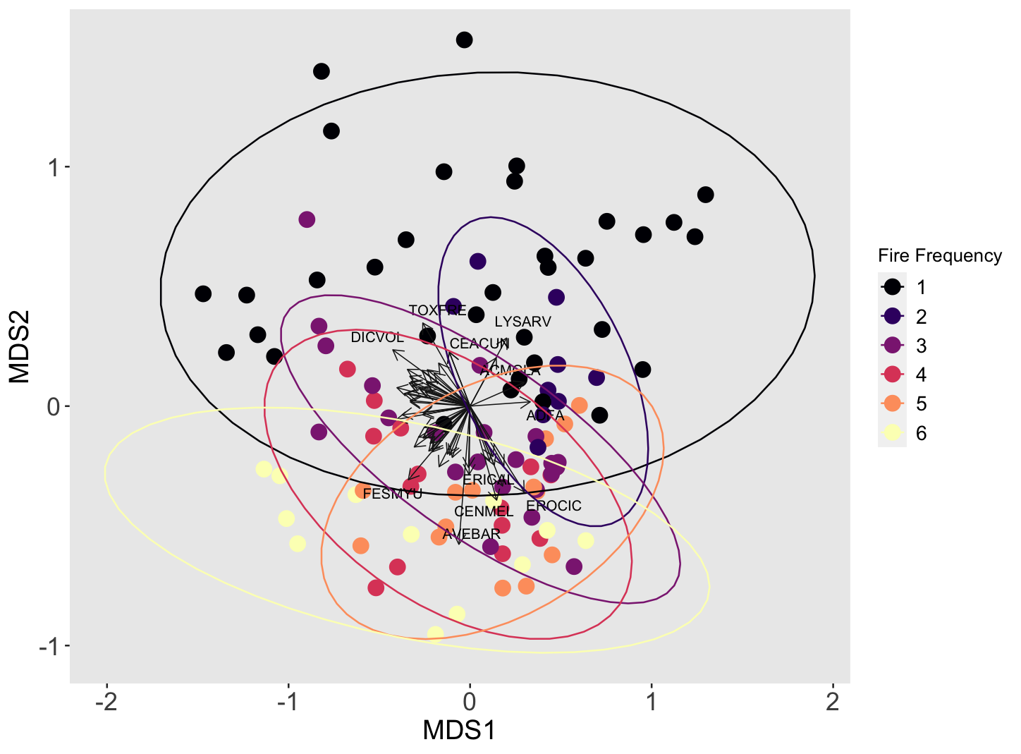

​​

*Fig 4: Non-metric multidimensional scaling plot (NMDS) of Bray-Curtis dissimilarity matrix across fire frequency. Each point represents a survey point. Plots with higher fire recurrence (pink, orange, and yellow) are more clustered together, indicating that they have a more similar species composition than plots with lower fire recurrence (black, dark blue, purple). Labeling priority was given to more abundant and frequent species. Species codes:* ACMGLA *Acmispon glaber,* ACMWRA *Acmispon wrangelianus,* ADFA *Adenostoma fasciculatum,* ASTGAM *Astragalus gambelianus,* AVEBAR *Avena barbata,* CEACUN *Ceanothus cuneatus,*CENMEL *Centaurea melitensis,* CLAUNG *Clarkia unguiculata,* DICVOL *Dichelostemma volubile,* ERICAL *Eriodictyon californicum,* EROCIC *Erodium cicutarium, ESCCAE Eschscholzia caespitosa,* FESMYU *Festuca myuros,* LYSARV *Lysimachia arvensis,* MELTOR *Melica torreyana,* NEMMEN *Nemophila menziesii,* STARIG *Stachys rigida,* TOXFRE *Toxicodendron fremontii,* TRIMIC *Trifolium microcephalum,* TRIMIC2 *Trifolum microdon. Final stress of three dimensional solution = 0.166 after 24 iterations.*

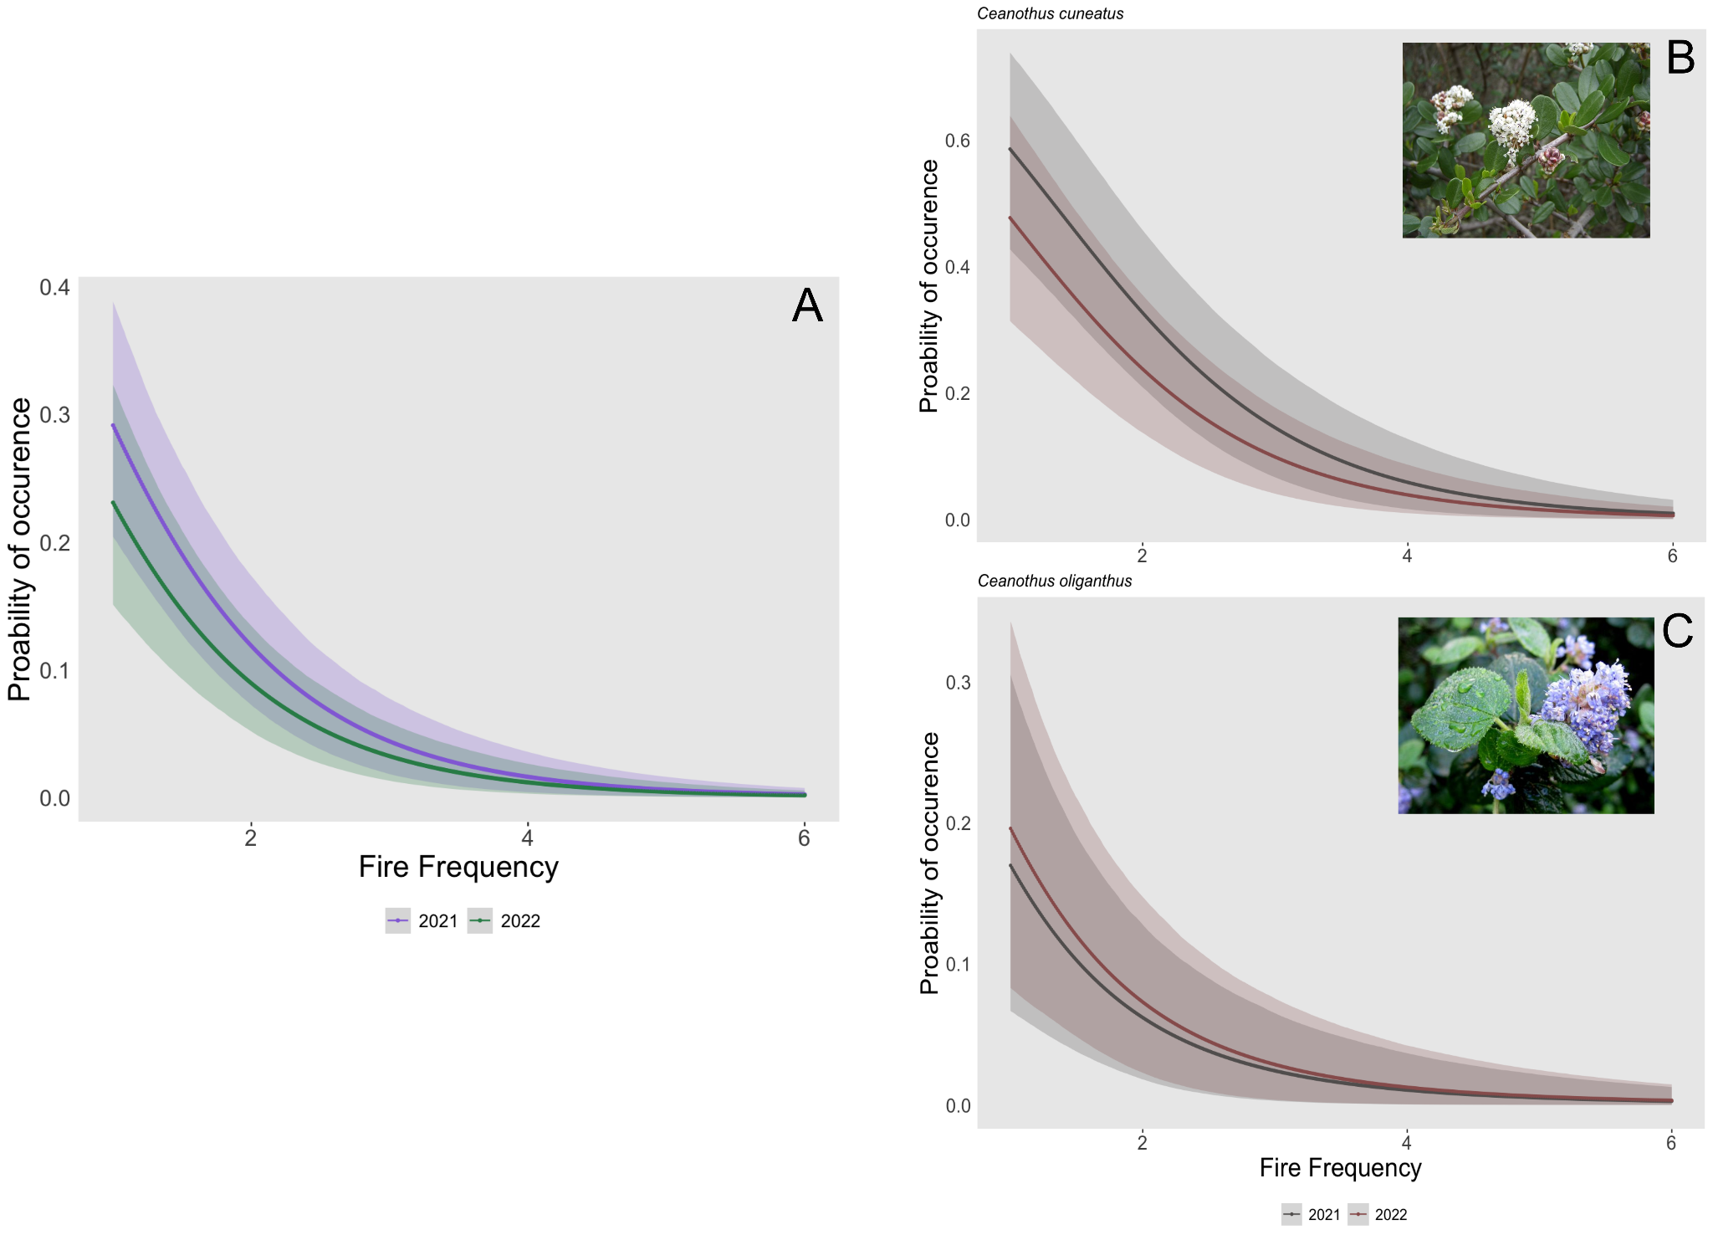

Fig 5: The probability of occurrence of an obligate seedling (A), including *Ceanothus cuneatus* (B) and *Ceanothus oliganthus* (C), declines with increased fire frequency in both survey years (2021 & 2022). The probability of occurrence is the presence of at least one seedling in the 250m2 plot. Error bars show 95% CIs.

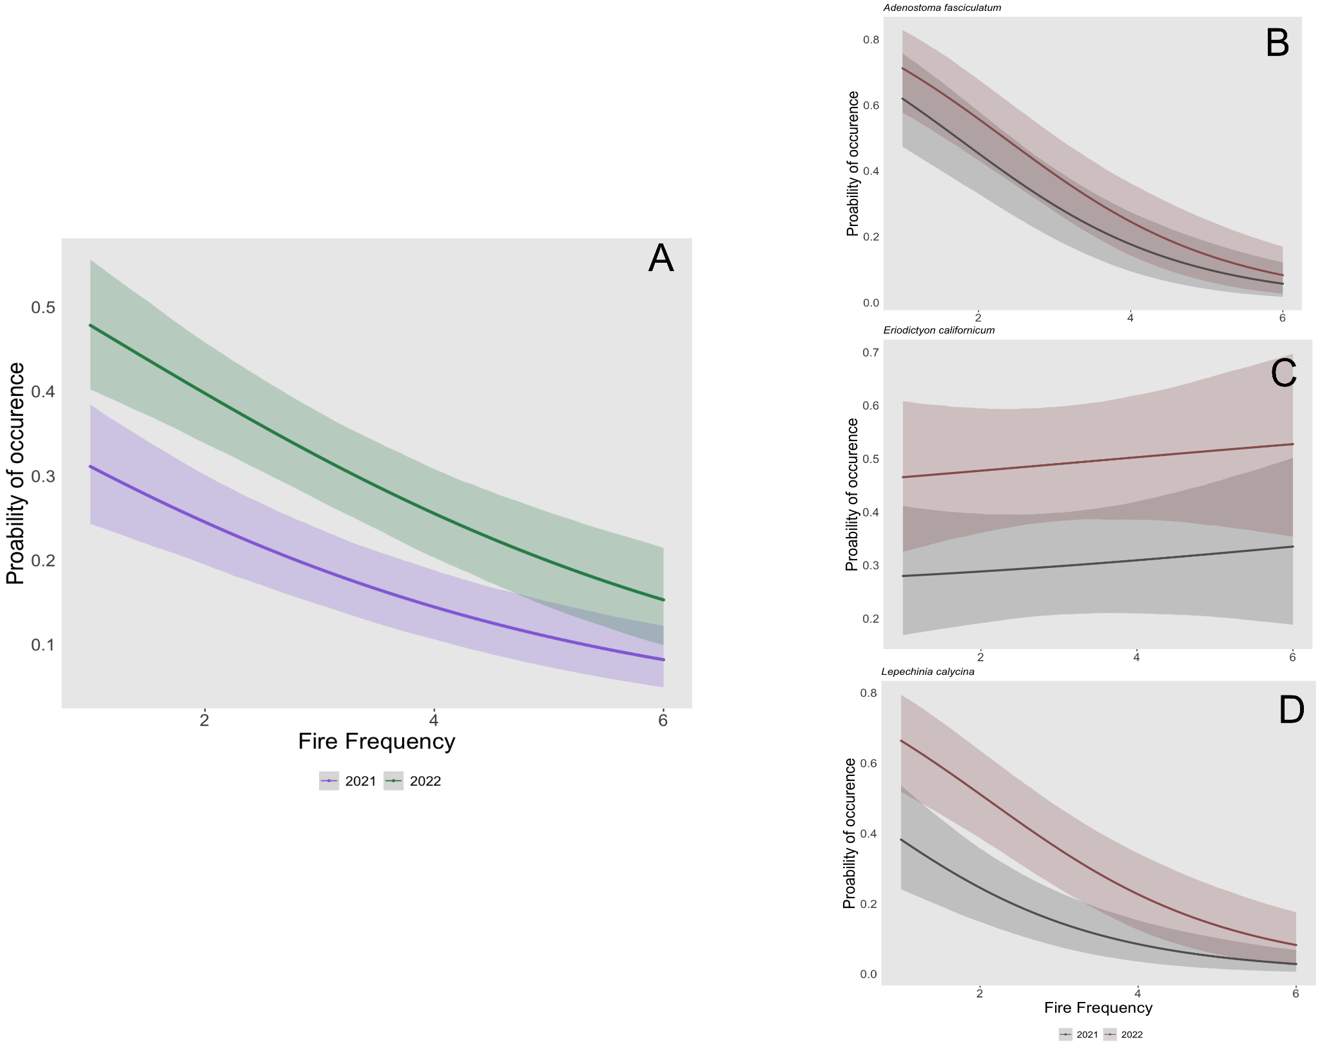

Fig 6: The probability of occurrence of a facultative seedling (A) declines with increased fire frequency in both survey years (2021 & 2022). This relationship was species-dependent, and fire frequency had little change on the probability of occurrence of an *Eriodictyon californicum* seedling (C), but decreased the probability of occurrence for *Adenostoma fasciculatum* (B) and *Lepechinia calycina* (D) seedlings. The probability of occurrence is the presence of at least one seedling in the 250m2 plot. Error bars show 95% CIs.

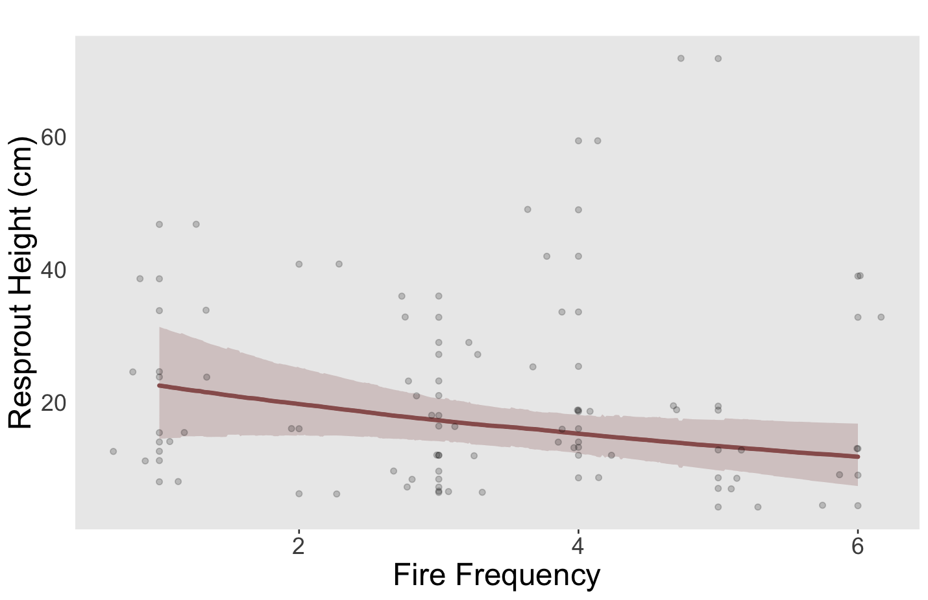

Fig. 7: Resprout height (cm) of facultative species does not significantly change with increased fire frequency. Error bars show 95% CIs.

# Discussion

* To add: Some studies have examined the effects of increased fire frequency in southern California but to date, no study has examined these effects at sites that have burned up to five times. Additionally, only a handful of studies have focused on the Coast Range of northern California, one of the most frequently burned locations in the whole state.

# Literature Cited

Abatzoglou JT, Williams AP (2016) Impact of anthropogenic climate change on wildfire across western US forests. Proc Natl Acad Sci 113:11770-11775.

Keeley, J.E., and C.J. Fotheringham. 2001. Historic fire regime in southern California shrublands. Conserv Biol 15 (6): 1536–1548. https://doi.org/10.1046/j.1523-1739.2001.00097.x.

Keeley JE, Fotheringham CJ (2003) Impact of past, present, and future fire regimes on North American Mediterranean shrublands. In ‘Fire and Climatic Change in Temperate Ecosystems of the Western Americas’. (Eds TT Veblen, WL Baker, G Montenegro, TW Swetnam) pp. 218–262. (Springer-Verlag: New York)

Keeley, J.E., and H.D. Safford. 2016. Fire as an ecosystem process. Pp. 27-45, in H.A. Mooney and E. Zavaleta (eds). Ecosystems of California. University of California Press, Berkeley, CA.

Park I, Hooper J, Flegal JM, Jenerette GD (2018) Impacts of climate, disturbance, and topography on distribution of herbaceous cover in Southern California chaparral: insights from a remote sensing method. Divers Distrib 24:497–508

Safford, H.D., A.K. Paulson, Z.L. Steel, D.J.N. Young, and R.B. Wayman. 2022. The 2020 California fire season: A year like no other, a return to the past, or a harbinger of the future? Global Ecology and Biogeography. DOI: 10.1111/geb.13498

Syphard, Alexandra D., Janet Franklin, and Jon E. Keeley. "Simulating the effects of frequent fire on southern California coastal shrublands." *Ecological Applications* 16.5 (2006): 1744-1756.

Syphard, Alexandra D., Keith C. Clarke, and Janet Franklin. "Simulating fire frequency and urban growth in southern California coastal shrublands, USA." *Landscape ecology* 22 (2007): 431-445.

Syphard AD, Brennan TJ, Keeley JE (2019) Drivers of chaparral type conversion to herbaceous vegetation in coastal Southern California. Divers Distrib 25:90–101

Van de Water K, Safford HD (2011) A summary of fire frequency estimates for California vegetation before Euro-American settlement fire. Ecology 7:26–58.

Werner, C., S.P. Harrison, H.D. Safford, G. Bohlman, and R. Serata. 2021. Extreme pre-fire drought decreases shrub regeneration on fertile soils. Ecological Applications: e02464

***FROM RFP***

Balch JK, Bradley BA, D'Antonio CM, Gómez-Dans J (2013) Introduced annual grass increases regional fire activity across the arid western USA (1980–2009). Glob Change Biol 19:173–183.

D’Antonio CM, Vitousek PM (1992) Biological invasions by exotic grasses, the grass/fire cycle, and global change. Annu Rev Ecol Syst 23:63–87

Bates D, Mächler M, Bolker B, Walker S (2015) Fitting Linear Mixed-Effects Models Using lme4. J Stat Softw 67.

Eldridge DJ, Bradstock RA (1994) The effect of time since fire on the cover and composition of cryptogamic soil crusts on a eucalypt shrubland soil. Cunninghamia 3:521–527.

Flannigan MD, Stocks BJ, Wotton BM (2000) Climate change and forest fire. Sci Total Environ 262:221-229.

Forest Climate Action Team (2018) California Forest Carbon Plan: Managing Our Forest Landscapes in a Changing Climate. Sacramento, CA. 178 pp.

Governor’s Forest Management Task Force (2021) California’s Wildfire and Forest Resilience Action Plan. Sacramento, CA. 88 pp.

He T, Lamont BB, Pausas JG (2019) Fire as a key driver of Earth’s biodiversity. Biol 94:1983-2010.

Hooper DU, Chapin FS, Ewel JJ, Hector A, Inchausti P, et al. (2005) Effects of biodiversity on ecosystem functioning: a consensus of current knowledge. Ecol Monogr 75:3–35.

Keeley JE, Zedler PH (1998) Evolution of life histories in Pinus. In: Richardson DM (ed) Ecology and biogeography of Pinus. Cambridge University Press, Cambridge, pp 219–250.

Keeley JE (2004) Invasive plants and fire management in California Mediterranean- climate ecosystems. In: Proceedings 10th MEDECOS Conference.

No Author. (2019). TRY plant trait database. Retrieved from www.try-db.org.

Pausas JG, Bradstock RA, Keith DA, Keeley JE (2004) Plant Functional Traits in Relation to Fire in Crown-Fire Ecosystems. Ecology 85:1085-1100.

Raunkiaer C (1934) The Life Forms of Plants and Statistical Geography. Clarendon Press, Oxford.

Rundel PW (2018). California chaparral and its global significance. In EC Underwood, HD Safford, NA Molinari, & JE Keeley (Eds.), Valuing chaparral: Ecological, socio-economic, and management perspectives (pp. 1– 27). Springer International Publishing.

Underwood EC, Franklin J, Molinari NA, Safford HD (2018) Global Change and the Vulnerability of Chaparral Ecosystems. Bull Ecol Soc Am 99:1–10.

Underwood, E.C., H.D. Safford, N.A. Molinari, and J.E. Keeley, eds. 2018. Valuing chaparral: ecological, socioeconomic, and management perspectives. Springer, Cham, Switzerland.

Westerling AL, Bryant BP (2008) Climate change and wildfire in California. Clim Change 87:S231–S249.

Wright IJ, Reich PB, Westoby M, Ackerly DD, Baruch Z, et al. (2004) The worldwide leaf economics spectrum. Nature 428:821-827.

Zedler PH, Gautier CR, & McMaster GS (1983) Vegetation Change in Response to Extreme Events: The Effect of a Short Interval between Fires in California Chaparral and Coastal Scrub. Ecology 64:809.